**IMPORTANT:** When, installing the rpi manager, install the version more than 1.8, else you will not be able to fix the errors while you boot the os to SD card .

So to make it , do not use commands to install directly from the hub. But download and then make it use commads to install, so that the right and newer version will be installed.

use this command:

**sudo -E rpi-imager**

This is used for resolving the issues with the environment. -E. Especially with the gui based applications.

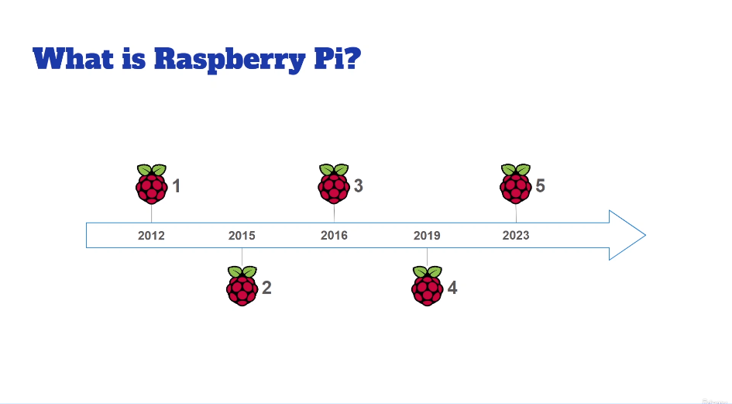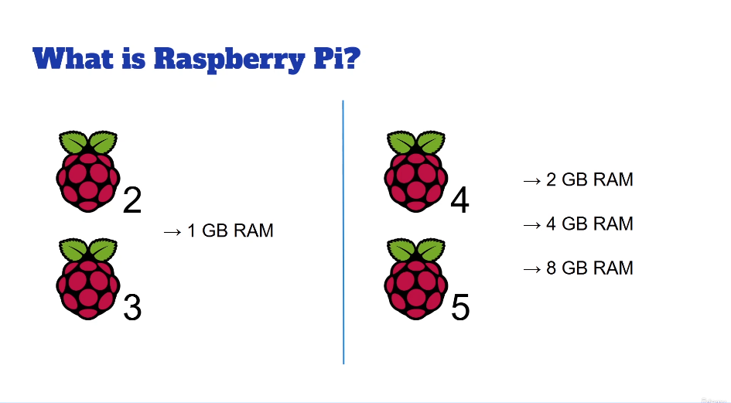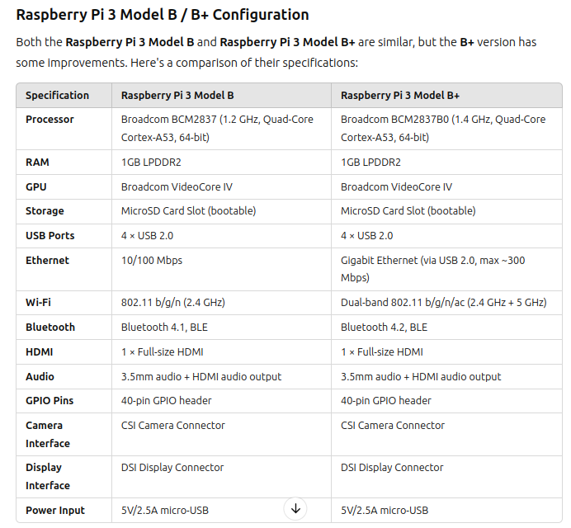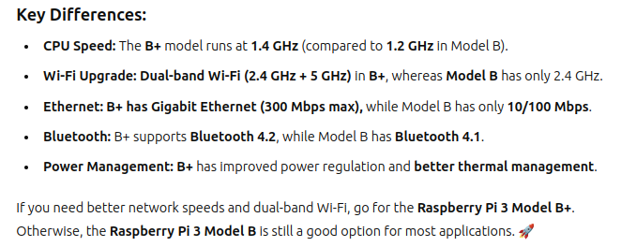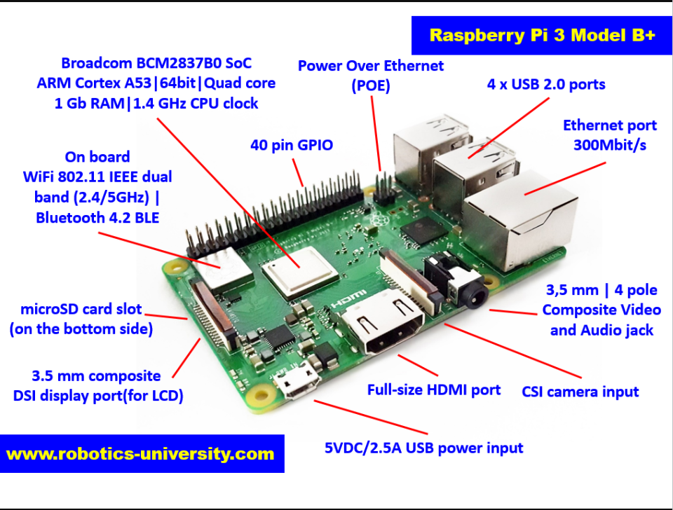

Sure! Here’s a **detailed explanation** of each part of the **Raspberry Pi 3 Model B+**, explaining **how it works and what you can do with it**, just like your example.

### ****1. USB Ports****

**What it does:** The Raspberry Pi 3 Model B+ has **4 USB 2.0 ports**.

**How it is used:**

You can **connect a USB flash drive (pendrive)** to transfer data.

A **USB keyboard and mouse** can be connected to control the Pi.

**External hard drives** can be attached to store large amounts of data.

A **USB webcam** can be connected for video calls or security cameras.

**Example Project:**

**Network-Attached Storage (NAS):** Use an external hard drive with the Raspberry Pi to create a personal cloud storage system.

### ****2. Ethernet (LAN) Port****

**What it does:** This is a **wired network connection** port.

**How it is used:**

You can connect an **Ethernet cable** to access the internet with a more **stable connection** than WiFi.

Useful for **high-speed data transfer** (up to 300 Mbps).

**Example Project:**

**VPN Server:** Use the Raspberry Pi to set up a **Virtual Private Network (VPN)** for secure remote access to your home network.

### ****3. HDMI Port (High-Definition Multimedia Interface)****

**What it does:** Outputs **video and audio** to a display.

**How it is used:**

Connect to a **TV or monitor** to display the Raspberry Pi interface.

Supports **HD video output**, making it ideal for **watching movies, running a digital signage display, or playing games**.

**Example Project:**

**Home Media Center:** Install **Kodi** to stream movies and TV shows from the Raspberry Pi to a TV.

### ****4. 3.5mm Audio and Composite Video Jack****

**What it does:** Outputs **stereo audio** and **composite video** for older TVs and speakers.

**How it is used:**

Connect to **speakers or headphones** for audio output.

Used for **old CRT televisions** that don’t support HDMI.

**Example Project:**

**Internet Radio Player:** Stream music from the internet and play it through speakers.

### ****5. CSI Camera Port (Camera Serial Interface)****

**What it does:** Allows connection of a **Raspberry Pi Camera Module**.

**How it is used:**

Used for **capturing photos and recording videos**.

Can be used for **computer vision projects** like **face recognition**.

**Example Project:**

**Smart Security Camera:** Detect motion and send alerts using the Raspberry Pi camera module.

### ****6. Micro USB Power Port (5V DC)****

**What it does:** This is where the **power adapter** is connected.

**How it is used:**

The Raspberry Pi **requires a 5V/2.5A power supply**.

Can also be powered using a **portable battery pack**.

**Example Project:**

**Portable Game Console:** Use a **power bank** to make a handheld **RetroPie emulator**.

### ****7. GPIO Pins (General-Purpose Input/Output)****

**What it does:** A **40-pin header** used to connect **sensors, motors, LEDs, and other electronic components**.

**How it is used:**

Can control **LED lights** to blink or display patterns.

Can read input from **buttons, sensors, and touchpads**.

Can send signals to control **relays, motors, and automation systems**.

**Example Project:**

**Home Automation System:** Control **lights and appliances** using relays and Raspberry Pi.

### ****8. Power Over Ethernet (PoE) Connector****

**What it does:** Allows the Raspberry Pi to be powered using an **Ethernet cable** (requires a PoE HAT).

**How it is used:**

Eliminates the need for a separate **power adapter**.

Useful for **remote installations** where power outlets are unavailable.

**Example Project:**

**Outdoor IoT Weather Station:** Deploy a Raspberry Pi-powered weather station **on a rooftop** using PoE.

### ****9. MicroSD Card Slot****

**What it does:** Stores the **operating system and files** of the Raspberry Pi.

**How it is used:**

A **MicroSD card** (8GB or larger) is required to run **Raspberry Pi OS or other Linux distributions**.

Can be used to **store data for projects** like IoT applications or security systems.

**Example Project:**

**Offline Wikipedia Server:** Store Wikipedia on an SD card to access articles **without the internet**.

### ****10. WiFi and Bluetooth (802.11ac WiFi + Bluetooth 4.2 BLE)****

**What it does:** Enables **wireless internet and Bluetooth communication**.

**How it is used:**

Connect to a **WiFi network** for internet access.

Use **Bluetooth to connect a wireless keyboard, mouse, or speakers**.

**Example Project:**

**Smart Door Lock:** Unlock a door using **Bluetooth authentication** from a smartphone.

### ****11. SoC (System on Chip) - Broadcom BCM2837B0****

**What it does:** This is the **main processor** of the Raspberry Pi, which combines:

**CPU (Cortex-A53 64-bit 1.4GHz quad-core processor)** → Handles all computations.

**GPU (Graphics Processing Unit)** → Handles video output and graphical tasks.

**How it is used:**

Runs applications like **web browsers, games, and programming environments**.

Supports **machine learning and AI-based projects**.

**Example Project:**

**AI-Powered Object Detection:** Use TensorFlow to detect objects **in real-time**.

### ****12. RAM (1GB LPDDR2 Memory)****

**What it does:** Acts as **temporary memory** to store and process data while the Raspberry Pi is running.

**How it is used:**

The **more RAM, the faster applications can run**.

Important for **multitasking and running large programs**.

**Example Project:**

**Web Server:** Host a **personal website or blog** using the Raspberry Pi.

## ****Summary Table of Raspberry Pi 3 Model B+ Components and Their Uses****

| **Component** | **Function** | **Real-World Project** |
| --- | --- | --- |
| **USB Ports** | Connects peripherals like flash drives, keyboards, and webcams. | **USB storage system, Smart Camera** |
| **Ethernet (LAN) Port** | Provides wired internet connection. | **VPN server, NAS system** |
| **HDMI Port** | Outputs video to a monitor/TV. | **Home media center, Digital signage** |
| **3.5mm Audio Jack** | Outputs audio for speakers/headphones. | **Internet radio, Voice assistant** |
| **CSI Camera Port** | Connects a camera module. | **Smart security camera, Face recognition** |
| **Micro USB Power Port** | Provides 5V power to the Pi. | **Portable gaming console, Solar-powered Pi** |
| **GPIO Pins** | Connects sensors, motors, and electronics. | **Home automation, Robotics** |
| **PoE Connector** | Powers the Pi via Ethernet cable. | **Remote IoT sensors, Surveillance camera** |
| **MicroSD Card Slot** | Stores the operating system and data. | **Offline Wikipedia, IoT data logger** |
| **WiFi & Bluetooth** | Enables wireless communication. | **Smart door lock, Wireless IoT device** |
| **SoC (CPU + GPU)** | Runs programs and processes data. | **AI object detection, Game development** |
| **RAM (1GB)** | Provides temporary memory for programs. | **Web hosting, Machine learning tasks** |

This guide should give you a **clear and practical understanding** of how each part of the Raspberry Pi 3 Model B+ can be used in real-world projects!

**Do’s**:

You directly pass the power through the adapter, not from the usb of the laptop, since th epower required is not suffiecient, even the LED is on.

There might be issues.

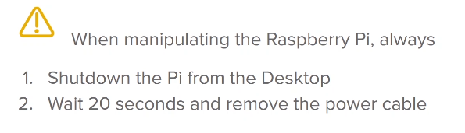

**Flashing the OS of Raspberry Pi:**

1. Raspberry pi, ---> /software
2. command to install the raspberry pi manager(imager)
   1. sudo apt install rpi-imager
   2. lsusb - check all the usb available.
   3. Info:
      1. **rpi-imager --version**
      2. **sudo rpi-manager**  :
         1. It opens manager terminal box. This is to be used, otherwise there are high chances that it might give error.

when sudo -E rpi-manager, is giving me wrong:

* + - 1. which rpi-manager

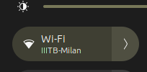



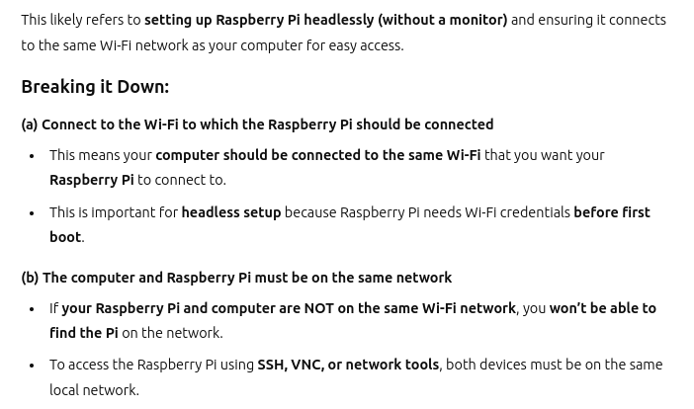



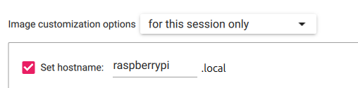

* 1. When you are instaling th ros to many devices, then you need to change the name here for every raspberry pi board manager.

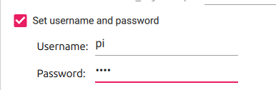

* 1. The entry of the raspberry pi

1. Set the Username and the password

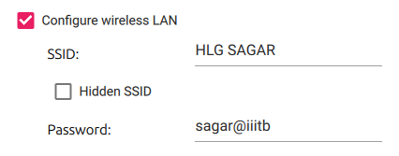



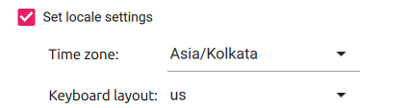



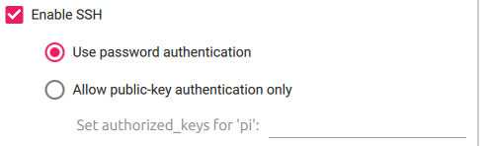



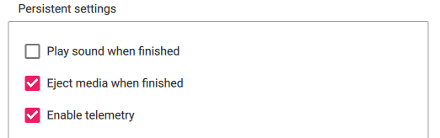

1. Click on continue and then remove it.

Problem with the writing

After this click on write then it will start to write into the sd card. But if you cancel the write then the partition will go off, then what ypu should do is mentioned in the file = “When the sd card not partitioned”

So currently I ahev connected with the mobile hotspot. Then you need to use this to make the connecteion and data transfers.

After the booting is done,put the sd card in its slot, then start working. The color should change from green to red. Green means loading , red means loaded.

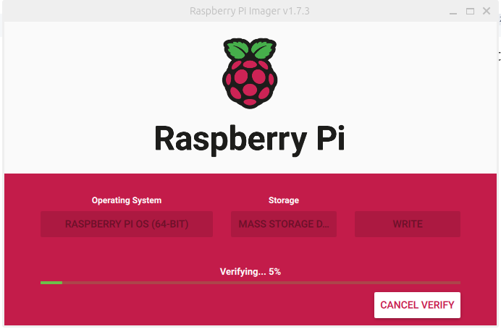

It has been downloaded, it is getting verified, then it goes for the next level.

**CONNECTING THE BOOATABLE TO THE RASPBERRY PI**

The led must convert from red to green. Then means, it is converting from t

**IP ADDRESS OF THE RASPBERRY PI**

Summary:

1. Angry scanner finds the ip
2. we need to enter the ip range
3. Connect tye hostname to wifi
4. Sort by ping.
5. Then you can see the hostname.
6. Raspberry pi.
7. Then it must be able find the ip address of the rapberry pi.
8. Finding the raspberry pi ip address. - Angry IP scanner
   1. Download the software in debian, since my laptop is ubuntu.

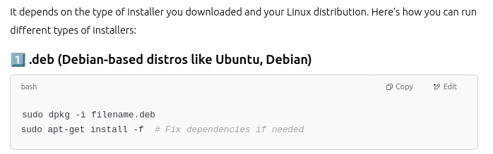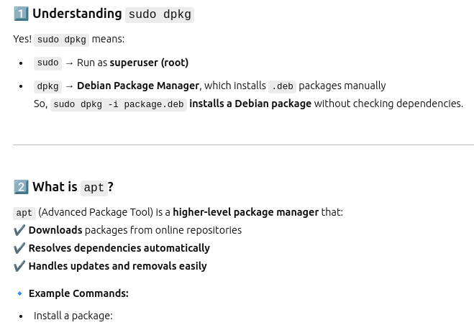

give the range in the raspberry in the angry scanner, then start to search. Then yoy will be getting the list of devices.

Sort by ping.

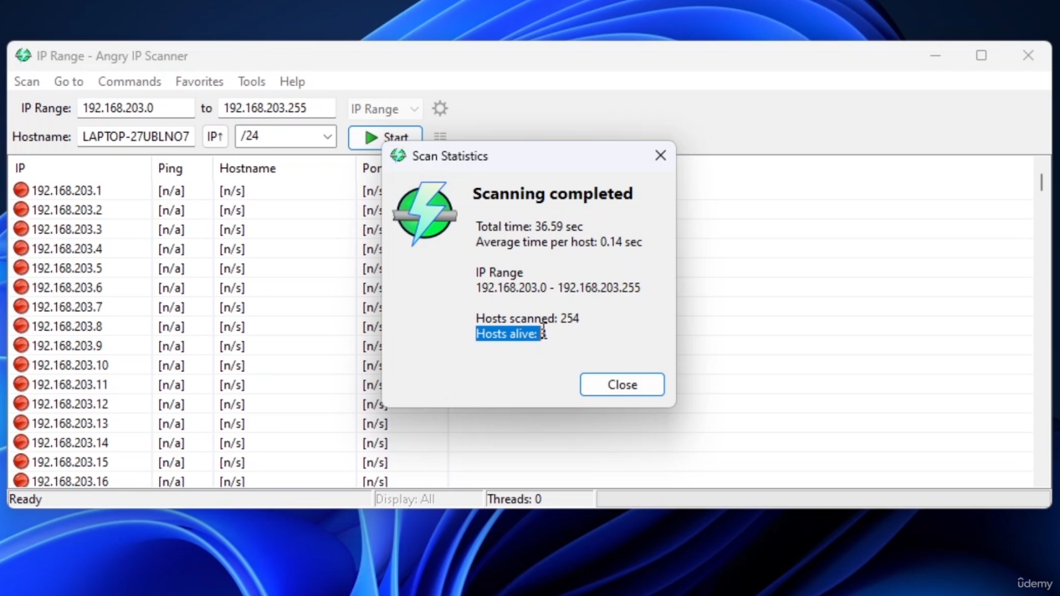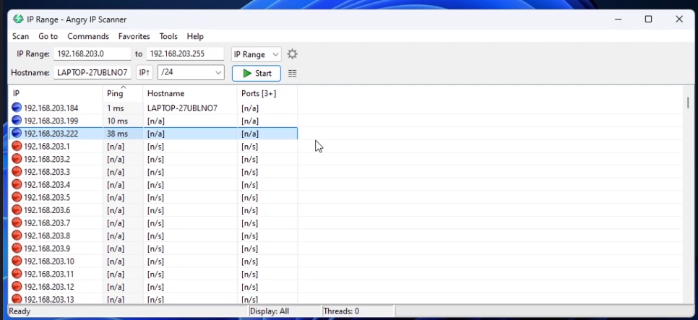

The host name given in the settings of the rpi-manager, have to be shown in the hostname.

Since I have not connected to the

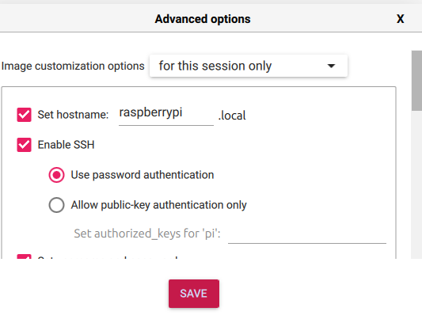

This to be shown. This hostname to be shown in the hostname. if the name is not shown, wait for time , even then it do not worked, then means you have some issues while making the settings.

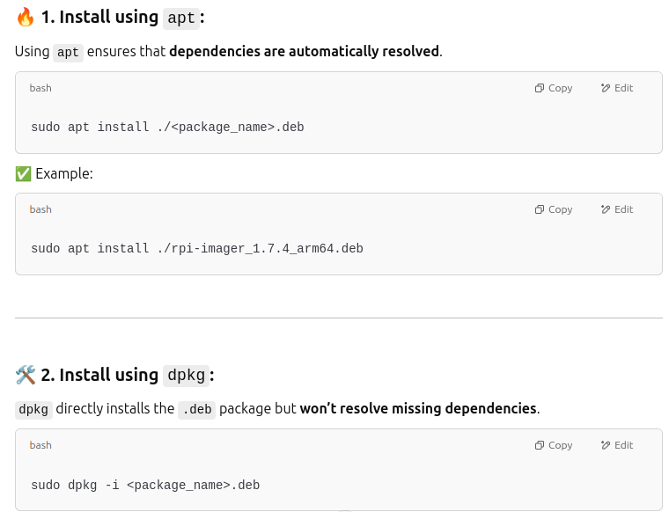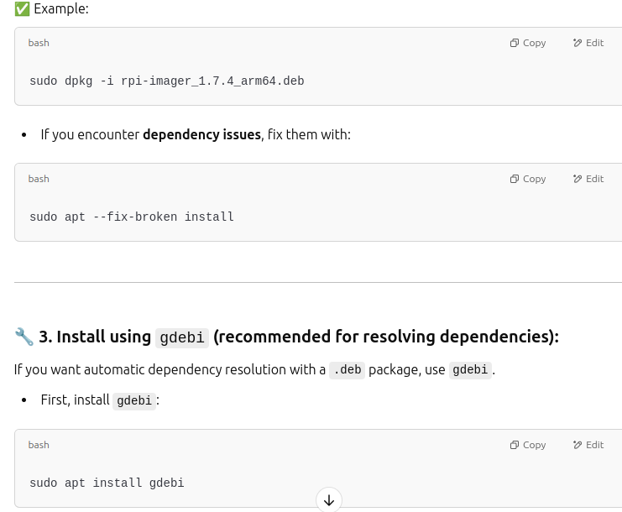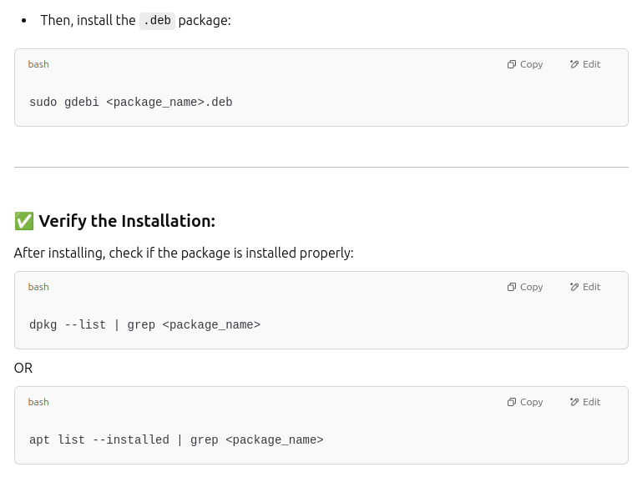

To remove the installed package from the ubuntu, use this command

**sudo apt remove rpi-imager**

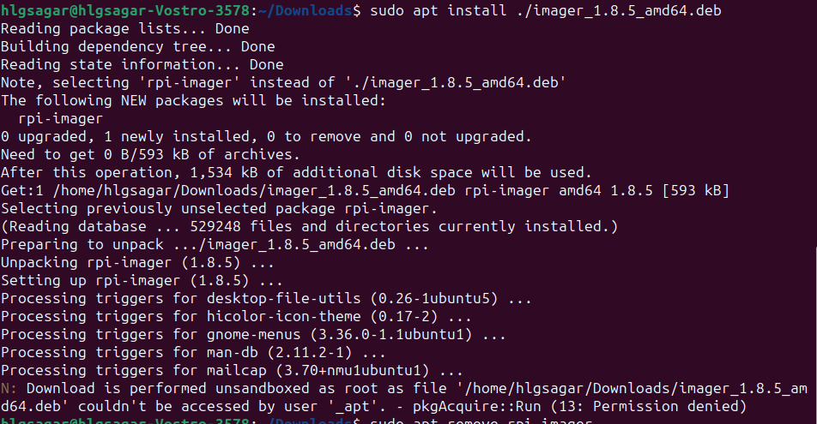

This was the error,

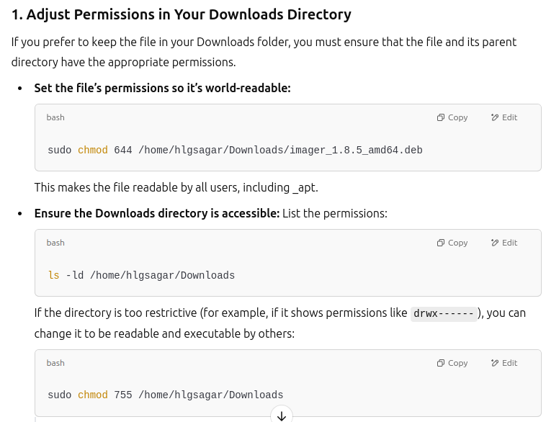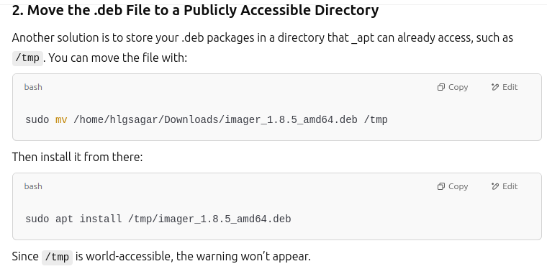

**This was the solution**.

**SSH over Raspberry pi to control from laptop terminal**

1. **VNC** - That is used to allow the raspberry pi desktop in my laptop.
2. Commands:
   1. ssh username_raspberrypi@ip address
   2. Password:
3. After completing the work: exit.
4. Commands in raspberry pi:
   1. sudo raspi-config
   2. Interfac-options:

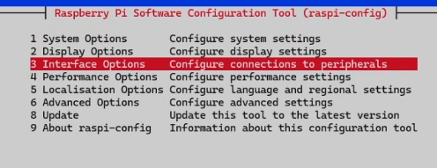

* 1. VNC :

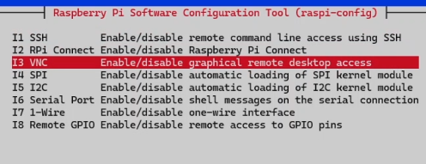



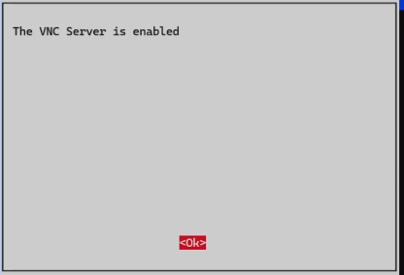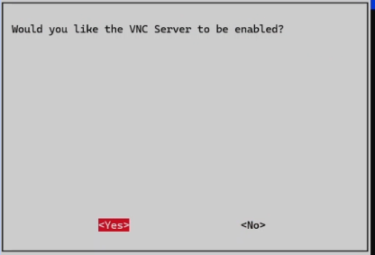

* + 2. Tiger VNC Then install, then run anyway.

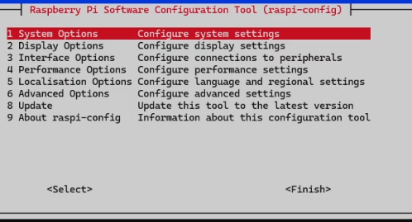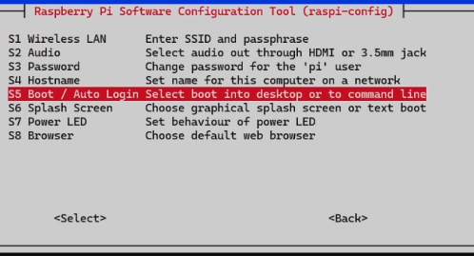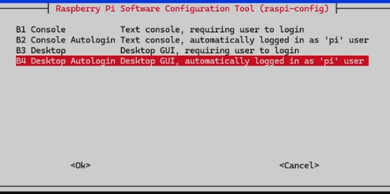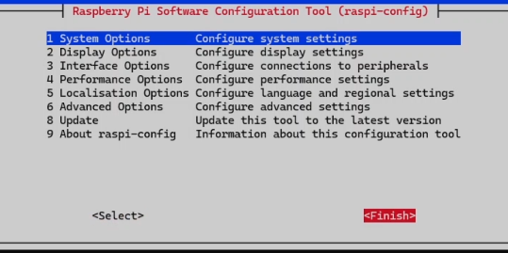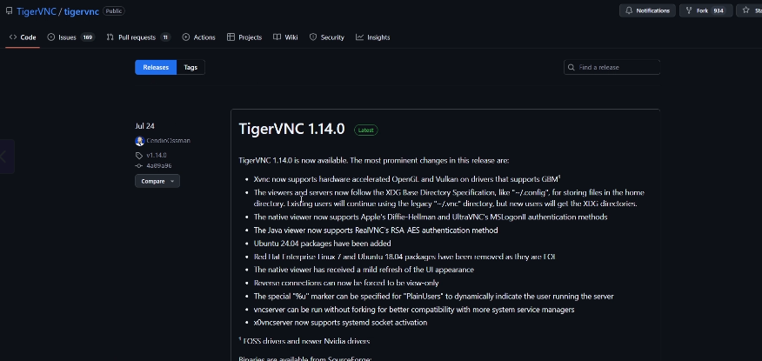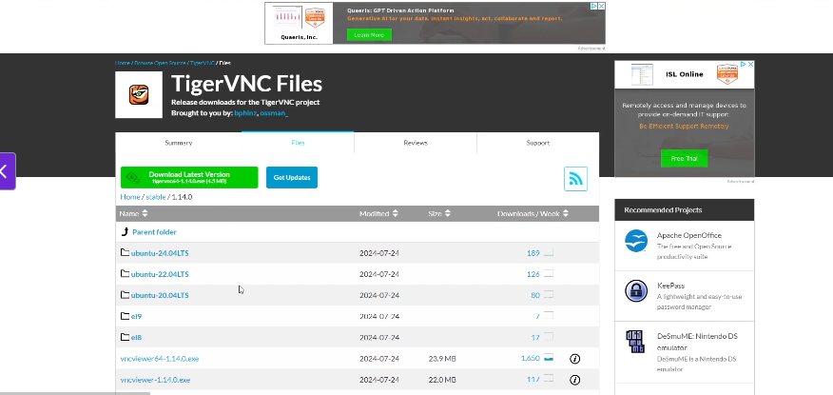

* + 1. Then open from your terminal then run it.
    2. Then enter the ip address of raspberry pi.
    3. The raspberry pi must be there from your own network, so that it can find the computer.
    4. Enter username and password. If this is working, VNC is working properly.
    5. This tiger-vnc will be opening the terminal in your laptop of the raspberry pi, so there is no need for HDMI, using ssh you can communicate with the raspberry pi.
  1. You have to configure the ip address some how, which keeps changing as the time progress.
  2. Go to the raspberry pi,
     1. Make updates and upgrades, sudo.

1. Final configurations:
   1. Press F8, the make the full-screen.
   2. Raspberry pi logo, then go the preferences and settings.
      1. Appearance settings.
      2. Raspberry pi configuarations, then change the host-name and the password, customise what you want.
      3. Update the version of the raspberry pi.
   3. - this is customised thing under the raspberry pi configurations.
2. Update- the raspberry pi.
3. Then shoutdown properly.

**ANOTHER WAY TO CONNECT TO RASPBERRY PI [ Through Web we can connect to Raspberry pi desktop]**

1. This works only with the newwr versions.
2. Raspberry pi connect- web account.
3. Sign in. and log in . [connect raspberry pi]
4. Connect the raspberry pi with the ssh.
   1. ssh pi@ip_address , this will take you towards the raspberry pi desktop.
   2. sudo apt upgrade
   3. Sudo apt install rpi-connect
   4. sudo reboot.
   5. After 50 seconds start to make to the connection again.
   6. rpi-connect signin
   7. The click on the link you have got.
   8. Then click on that you will be more like, getting into the raspberry pi board.
   9. Then screen sharing “connect via”, click on it.
   10. Then do whatever you want
   11. Then shutdown.

**CHANGE THE WIFI-SETTINGS[OPTIONAL]**

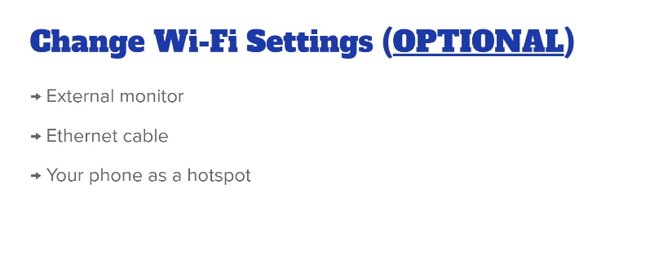

Solution

If all the above thing does not work, then start with this.

1. We will configure the hotspot on raspberry pi. When there is no wifi network the raspberry pi can connect, then this is hosted with the hotspot. While we still connected woth the wifi with the network.
2. Configure the hotspot in raspberry pi.
3. Connect to the raspberry pi, using VNC/ previous .
4. Go to advanced options->wireless hotspot.
5. Network Name; my rpi hotspot.
6. Wifi security: Personal and wpa
7. Passowrd: Give the password
8. As soon as connected then hotspot, the wifi will be stopped . This hostspot i shown on your laptop or device.
9. Tiger VNC, shall be closed.
10. Go to wifi settings in laptop, find the name what you have given for raspberry pi.
11. Then enter the password.
12. Now it must be connected to raspberry pi hotspot.
13. In the angry scanner, like connect yourself with the wifi, then check with all the raspberry pi ip addresses. You will get the raspberry pi ip address.
14. Then use the Tiger VNC to connect with the ip address that is shown, or pinged through the angry ip scanner.
15. Advanced options in the terminal opened using the vnc, ->edit options, then edit connections, then name of the hostspot, the configuaration settings, then general, and thenc onnect automatically then with priority, so the hotspot is created when we boot.
16. Then click on save then shutdown rasp.
17. Then going to any place where the wifi cannot be connected then, automatically the hostspot is on. When it cannot connect to any of the network.
18. Then reboot. The connect to the rasp using the wifi, hotspot on the raspr.
19. The same as the previous ip address and connect trouh the tiger VNC.

**Connecting to the new wifi.**

1. The new values of the hostname and the password properly, so we loose the connection with the tiger vnc.
2. Then hotspot is connection is lost.
3. The rasp and device must be connected to the new wifi.
4. Then we are going to make the connect once agin from start:
   1. Ip scanner
   2. Tiger vnc, apply the ip address
   3. Give craedentials.
   4. Then you are back again.
5. If no wifi is connected then hotspto will be connected automatically.
6. Removing the hotspot to connect automatically. Wireless and make the configuarations and make the solution.
7. Remove , connect automatically.

**PYTHON PROGRAMMING IN RASPBERRY PI**

1. In thonny in programming you can make the python programming.
2. It is IDE.
3. Switch to the regular mode, in thonny and then restart the thonny.
4. It is more like VS code. The python is already installed in it.
5. Store the code using text editor.

**BUILD RASPBERRY PI CIRCUIT**

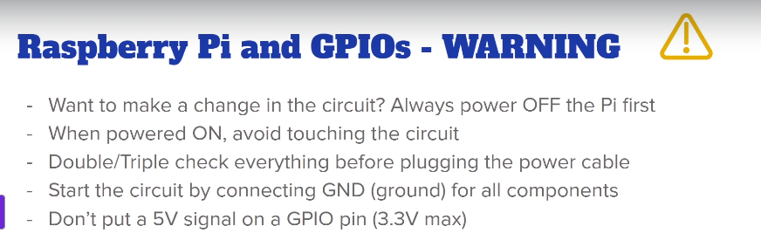



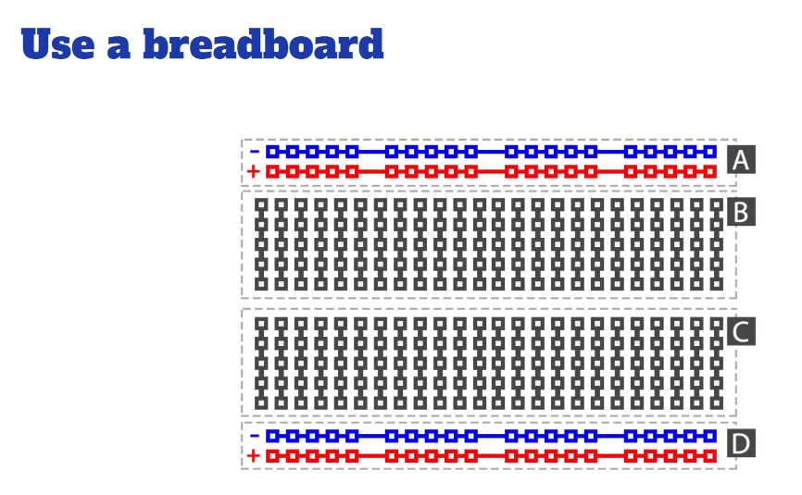





In the below the first one is having the gap between the two, so you need to make the connection betwen the different points in the bread board. Secons is series connected.

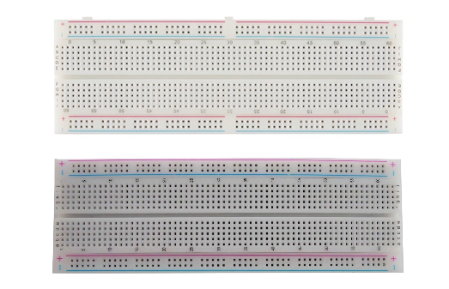



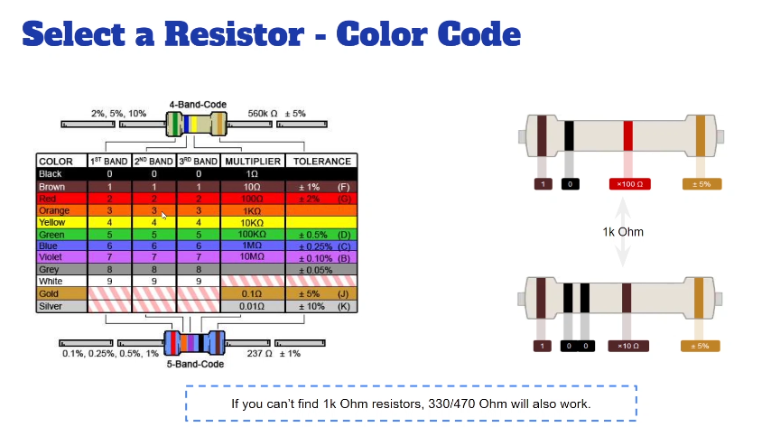

1. Use “fritizing” as the tool for making virtualisation.
2. Ground – black. The fifth pin from the wifi module is the ground pin.
3. Positive – red. [long leg side led]
4. Negative – blue.[ short leg side led ]

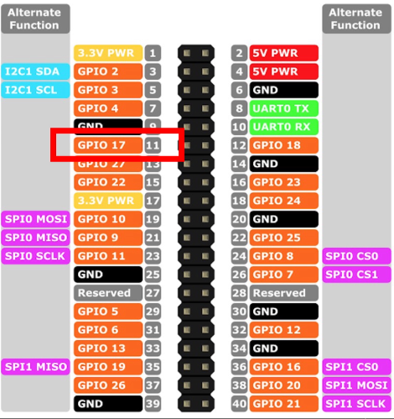



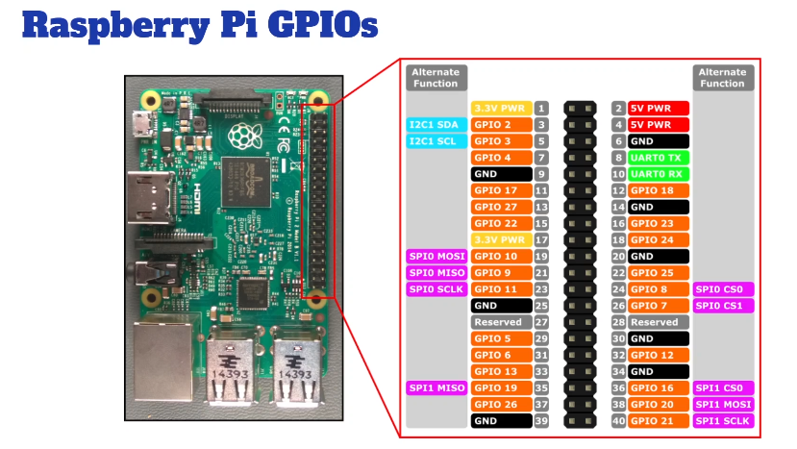

1. The numbers with gpio is used for making the communication using the python.
2. GPIO support 3.3 v not 5v.

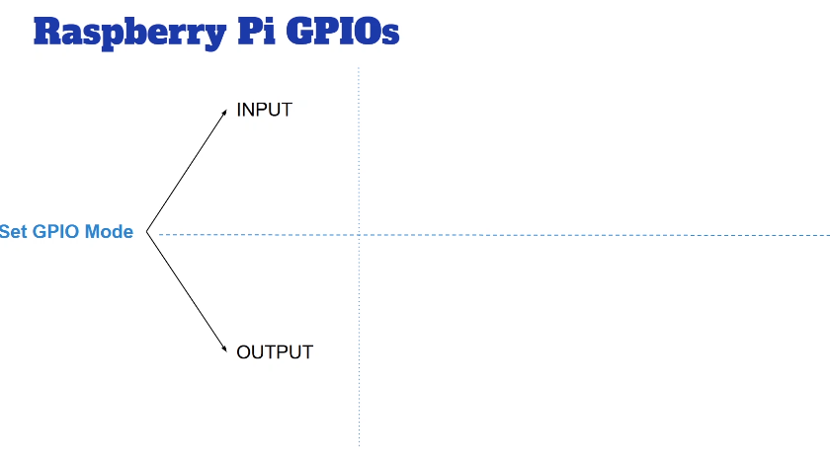

* 1. These GPIO’s to be used in order to make the communication, to set the input and output.

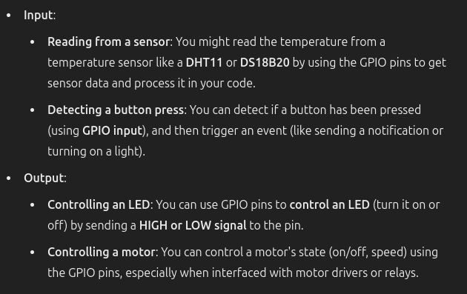

* 1. Input:
     1. Reading from a sensor: You might read the temperature from a temperature sensor like a DHT11 or DS18B20 by using the GPIO pins to get sensor data and process it in your code.
     2. Detecting a button press: You can detect if a button has been pressed (using GPIO input), and then trigger an event (like sending a notification or turning on a light).
  2. Output:
     1. Controlling an LED: You can use GPIO pins to control an LED (turn it on or off) by sending a HIGH or LOW signal to the pin.
     2. Controlling a motor: You can control a motor's state (on/off, speed) using the GPIO pins, especially when interfaced with motor drivers or relays.

1. s
2. s
3. s